Project Design Phase-II
Data Flow Diagram & User Stories
Date | 31 July 2026
Team ID | Team 1
Project Name | Employee Software Installation Request through Service Catalog
Maximum Marks | 4 Marks

Data Flow Diagrams:
A Data Flow Diagram (DFD) is a visual representation of the information flows within a system, showing how data enters and leaves the system, what changes the information, and where data is stored.
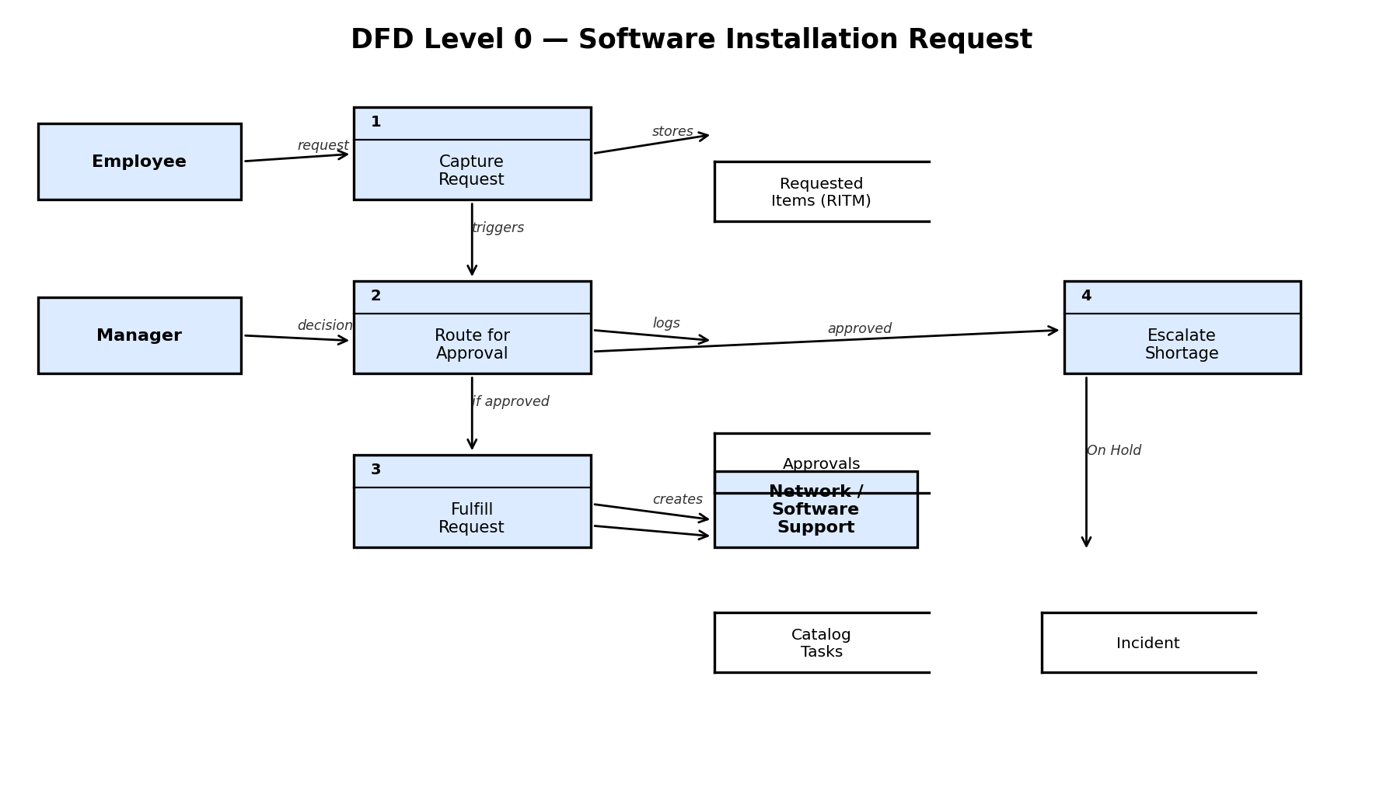
User Stories
Use the below template to list user stories for the solution.
User Type | Functional Requirement  (Epic) | User Story  Number | User Story / Task | Acceptance Criteria | Priority | Release
Employee | Request Submission | USN-1 | As an employee, I can submit a software installation request via the Service Catalog by filling software name, version, justification, device, license type, and required-by date. | Request is created with all fields captured correctly | High | Sprint-1
Employee | Request Submission | USN-2 | As an employee, I will receive a confirmation once my request is submitted. | Confirmation is visible on submission | Medium | Sprint-1
Employee | Status Tracking | USN-3 | As an employee, I can view the current status of my request under My Requests. | Status updates reflect Requested/Approved/Rejected/Closed | High | Sprint-1
Manager | Approval | USN-4 | As a manager, I can view pending software requests assigned to me under My Approvals. | Pending requests are listed with relevant details | High | Sprint-1
Manager | Approval | USN-5 | As a manager, I can approve or reject a request with comments. | Decision updates the request state and notifies the employee | High | Sprint-1
IT / Network Team | Fulfillment | USN-6 | As an IT team member, I receive a Catalog Task automatically when a request is approved. | Task is created with correct assignment group and details | High | Sprint-2
System | Escalation | USN-7 | As the system, I automatically raise an Incident when a request cannot be fulfilled due to license shortage. | Incident is created and assigned to Software Support with no manual step | Medium | Sprint-2

